Module 3
Assessment Questions:
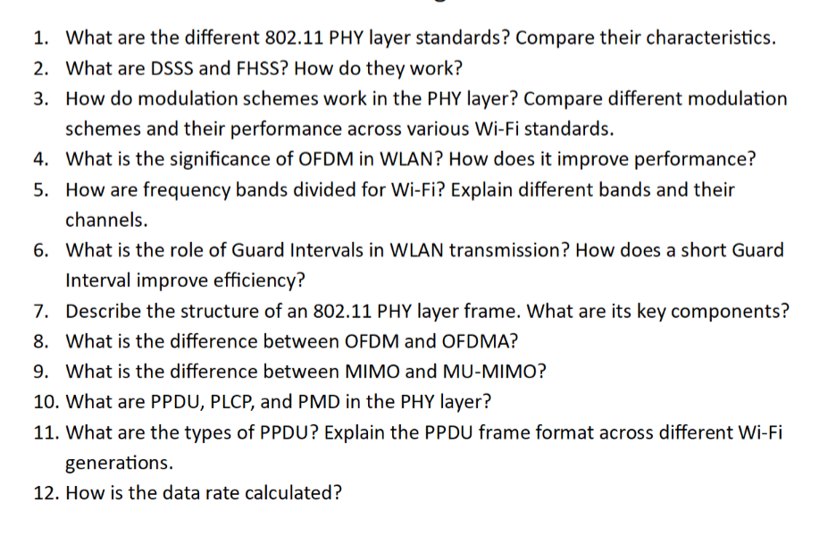
Answers :

1. What are the Different 802.11 PHY Layer Standards? Compare Their Characteristics

Introduction
The Physical Layer (PHY) in IEEE 802.11 defines how wireless signals are transmitted over radio frequencies. Each Wi-Fi generation introduced improvements in speed, frequency, modulation, and efficiency.

Major 802.11 PHY Standards
Standard | Year | Frequency | Maximum Data Rate | Key Technology
802.11 | 1997 | 2.4 GHz | 2 Mbps | FHSS/DSSS
802.11b | 1999 | 2.4 GHz | 11 Mbps | DSSS/CCK
802.11a | 1999 | 5 GHz | 54 Mbps | OFDM
802.11g | 2003 | 2.4 GHz | 54 Mbps | OFDM
802.11n | 2009 | 2.4/5 GHz | 600 Mbps | MIMO + OFDM
802.11ac | 2013 | 5 GHz | 6.9 Gbps | MU-MIMO
802.11ax | 2019 | 2.4/5/6 GHz | 9.6 Gbps | OFDMA + BSS Coloring
802.11be | Emerging | 2.4/5/6 GHz | 46 Gbps | Multi-Link Operation

Evolution Highlights

802.11b
- First widely adopted standard.
- Good range but limited speed.

802.11a
- Higher speed.
- Less interference.
- Shorter range.

802.11g
- Combined speed of 11a with range of 11b.

802.11n
- Introduced MIMO.
- Major performance leap.

802.11ac
- Wider channels.
- Beamforming.
- MU-MIMO.

802.11ax
- Designed for dense environments.
- Better efficiency than raw speed.

2. What are DSSS and FHSS? How Do They Work?

Frequency Hopping Spread Spectrum (FHSS)

Working Principle
- Signal rapidly hops between multiple frequencies.
- Both transmitter and receiver follow the same hopping sequence.

Advantages
- Resistant to interference.
- Better security.

Disadvantages
- Lower throughput.
- Complex synchronization.

Direct Sequence Spread Spectrum (DSSS)

Working Principle
- Each data bit is multiplied by a pseudo-random chip sequence.
- Spreads the signal over a wider bandwidth.

Advantages
- Better noise immunity.
- Higher reliability.

Disadvantages
- Uses more bandwidth.

Comparison
Feature | FHSS | DSSS
Speed | Lower | Higher
Security | Good | Better
Complexity | High | Moderate
Interference Resistance | Excellent | Very Good

3. How Do Modulation Schemes Work in the PHY Layer?

What is Modulation?
Modulation converts digital bits into radio waves by altering:
- Amplitude
- Phase
- Frequency

Common Wi-Fi Modulation Types
Modulation | Bits per Symbol
BPSK | 1
QPSK | 2
16-QAM | 4
64-QAM | 6
256-QAM | 8
1024-QAM | 10
4096-QAM | 12

Performance Comparison
- Higher-order modulation increases speed.
- Requires stronger signal quality.

Example
- Near AP: 1024-QAM
- Far from AP: QPSK

Across Wi-Fi Generations
- 802.11a/g: Up to 64-QAM
- 802.11n/ac: Up to 256-QAM
- 802.11ax: Up to 1024-QAM
- 802.11be: Up to 4096-QAM

4. What is the Significance of OFDM in WLAN?

Definition
Orthogonal Frequency Division Multiplexing divides a channel into many narrow subcarriers.

How It Works
- Data is split into parallel streams.
- Each stream uses a separate subcarrier.
- Subcarriers are mathematically orthogonal.

Benefits
- High spectral efficiency.
- Excellent multipath resistance.
- Reduced interference.
- Supports high data rates.

Why Important?
OFDM is the foundation of modern Wi-Fi standards from 802.11a onward.

5. How are Frequency Bands Divided for Wi-Fi?

2.4 GHz Band
- Range: 2.400–2.4835 GHz
- Channels: 1–14
- Non-overlapping: 1, 6, 11

5 GHz Band
- More channels.
- Less interference.
- Supports wider bandwidths.
Common channel groups:
- UNII-1
- UNII-2
- UNII-2 Extended
- UNII-3

6 GHz Band (Wi-Fi 6E/7)
- Massive spectrum availability.
- Supports many 160 MHz channels.
- No legacy device interference.

6. Role of Guard Intervals in WLAN

What is Guard Interval?
A small time gap inserted between OFDM symbols.

Purpose
- Prevents Inter-Symbol Interference (ISI).
- Handles multipath delay.

Standard vs Short GI
Type | Duration
Normal GI | 800 ns
Short GI | 400 ns

Benefits of Short GI
- Increases throughput by about 10%.
- Improves efficiency.

Limitation
- Works best in environments with minimal reflections.

7. Structure of an 802.11 PHY Layer Frame

PHY Frame = PPDU
Contains:

Preamble
- Synchronization.
- Channel estimation.

PLCP Header
- Rate information.
- Frame length.

PSDU
- Actual MAC frame payload.

Simplified Format

| Preamble | PLCP Header | PSDU |

8. Difference Between OFDM and OFDMA
Feature | OFDM | OFDMA
Access | Single User | Multiple Users
Resource Allocation | Entire Channel | Resource Units
Efficiency | Good | Excellent
Standard | Wi-Fi 4/5 | Wi-Fi 6/7

Key Difference
- OFDM serves one client at a time.
- OFDMA serves multiple clients simultaneously.

9. Difference Between MIMO and MU-MIMO

MIMO
- Multiple antennas.
- Improves single-user throughput.

MU-MIMO
- Multiple users served simultaneously.

Comparison
Feature | MIMO | MU-MIMO
Users | One | Multiple
Efficiency | High | Very High
Best For | Single client | Dense networks

10. What are PPDU, PLCP, and PMD?

PPDU
Physical Protocol Data Unit.
Entire PHY frame transmitted over air.

PLCP
Physical Layer Convergence Procedure.
- Converts MAC frames to PHY format.
- Adds preamble and header.

PMD
Physical Medium Dependent.
- Actual RF transmission.
- Modulation.
- Coding.
- Signal generation.

11. Types of PPDU Across Wi-Fi Generations

Legacy PPDU
- Used in 802.11a/b/g.

HT PPDU
- Used in 802.11n.

VHT PPDU
- Used in 802.11ac.

HE PPDU
- Used in 802.11ax.

EHT PPDU
- Used in 802.11be.

Common Components
- Legacy Preamble
- Signal Field
- Training Fields
- Data Field

12. How is Data Rate Calculated?

Formula

R= ​NSS​×NSD​×NBPSC​×CR​/ TSYM

Parameters
- NSS = Number of Spatial Streams
- NSD = Number of Data Subcarriers
- NBPSC = Bits per Subcarrier
- R = Coding Rate
- TSYM = Symbol Duration

Example
For 802.11ac:
- 80 MHz
- 2 Spatial Streams
- 256-QAM (8 bits)
- Coding Rate = 5/6
Results in approximately 866.7 Mbps.

Factors Affecting Data Rate
- Channel width
- Modulation
- Coding rate
- Spatial streams
- Guard interval

